Movement Module

The movement module encompasses everything related to the simulation of the movement a passenger would have felt inside the rocket. It should include every movement from the launch to the landing. This document will go over all of the important details that needs to be considered for this particular module

The goal: The goal of this module is to give the impression of movement to the user. In such, the bench it self should be able to move along certain axes. The important force we are trying to recreate is the acceleration. As we are accelerating, the body feels a force going against it’s forward direction. As we are decelerating the body is feeling a force on is backside. Therefor, the goal of this module will be to recreate these force.

The experience: The experience should initially start by simulating the launch of the rocket. As the rocket goes faster these movement will become more significant. As the rocket is reaching its maximum altitude, the movement would run backwards as to signal that the rocket is decelerating. When the rocket starts falling back unto earth the same movement for the acceleration would be made. Finally when the parachute is deployed, a sharp movement would be made to signal intense change in acceleration.

The mean: The movement will be made possible by the use of a controllable pivot like system and a controllable harness system. Acceleration will be simulated by the use of a gradual kick back system. Since we are trying to simulate an acceleration that is going against the gravitational force, we can use the gravitational pull to simulate it. To simulate declaration a gradual movement towards the initial position will describe the return to no force going against our body. Finally when we want to simulate a parachute opening a kick back kick forth movement will be necessary. The harness will do the same as we are accelerating it should get tighter as we are decelerating it should get looser. As we are falling back onto earth, the harness is even looser and the body is falling onto it and the compression give the felling of free falling. As the parachute is deployed the harness is getting momentarily tighter and then it gets back at it’s original strengths. The head system does the same as the harness.

The equipment: There are three major system in the movement module. The first one being the pivot system. The actual bench it self will be place on a pivot system that can tilt forward and backward. The system will feature a rotation from 0 to 180 degrees. In the first figure you see how the bench is placed in a 3d environment. As we can see in the second figure the bench can rotate in the yz plan for about 180 degrees. To make this pivot system work we would need to able to set the angle of the bench via a program.
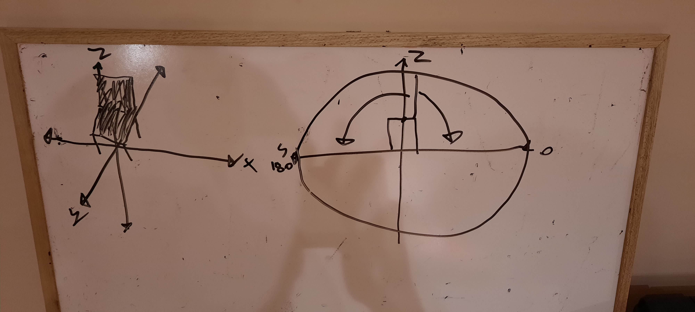
The next big equipment is an harness system that will be place at the chess of the user. This harness will press the user’s chess into the bench giving the impression of acceleration. Like the pivot system, the compression level should be controllable via a computer program.

The head system will work bot like the harness and the pivot. We want a tension system to be created in the back of the head to pull on it. The tension could be changeable via a computer program.

The science: The ideas behind this module is fairly simple we cannot recreate a force out of nothing on a static object. Therefor to recreate the acceleration we must use the gravity and other mechanism that mimics the feeling of acceleration. If we can convince the user that he is looking up and that the front of his body is facing that direction, than movement along the y axis will feel like he is accelerating.

Play by play:

#1 Launch:
the chair is starting to pivot backwards proportionnally to number of g force captured by the accelerometer

the harnest will begin to get tighter

the head system pulls the head back

#2 Ascention with combustion:
the chair is starting to pivot backwards proportionnally to number of g force captured by the accelerometer

the harnest will begin to get tighter

the head system pulls the head back

#3 Ascension with no combustion:
the chair is starting to pivot forward proportionnally to the number of G force captured by the accelerometer

the harnest will begin to loosen

the head system will beguin to release the head

#4 Maximum altitude:
The chair is brought back to it’s original state has is the harnest and the head system

#5 descente:

The chair is starting to pivot forward proportionnally to the number of G force captured by the accelerometer

the harnest will remain loosen

the head system will remain loosen

#6 first parachute:

the chair will have a huge kick back kick forward as to simulate a drastic change in velocity

harnest system will momentarily tighten than loosen

the head system will momentarily pull the head back and release it

#7 second parachute:
the chair will have a huge kick back kick forward as to simulate a drastic change in velocity

harnest system will momentarily tighten than loosen

the head system will momentarily pull the head back and release it

#8 Landing:

the chair is sudently brought back to it’s original state as is the harnest and the head system

